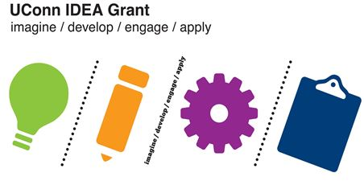UConn IDEA Grant

Sample Timeline Template

Project Goals and Target Outcomes (What are you hoping to accomplish?):

Target Project End-Date:

Timeline for accomplishing the goals by the target end-date:

|  |  |  |
| --- | --- | --- |
| Milestones | Dates/Weeks | Breakdown of Tasks |
| Milestone: Clearly defined measure of accomplishment of a task or sub task | How long do you think it will take to reach this project milestone? What dates or weeks will you focus on this segment of your project? | * Outline the steps you will need to take in the process * At the end of each step, include the amount of time you anticipate needing for each step |
| Milestone 1 | 3 weeks – (date – date) | * Step 1 (dates) * Step 2 (dates) * Step 3 (dates) * Step 4 (dates) |
| Milestone 2 |  |  |
| Milestone 3 |  |  |
| Milestone 4 |  |  |
|  |  |  |
|  |  |  |
|  |  |  |
|  |  |  |